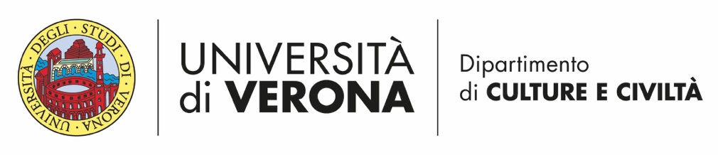

“Ilaria Caccia” Annual Scholarship
Fifth edition

Call for the years 2020-2024

The Department of Cultures and Civilisations of the University of Verona (www.dcuci.univr.it) and the Italian Association for Research on Dance (AIRDanza; www.airdanza.it) announce for the year 2024 a fifth edition of a competition for a study award dedicated to Ilaria Caccia, a young student at the University of Genoa, who departed prematurely; dance was for her an intensely lived passion.
Participation is reserved to the Master’s or doctoral theses discussed at Italian, European and non-European universities during the academic years 2020-2021, 2021-2022, 2022-2023 and 2023-2024.
Qualifying dissertations will regard dance history in general, with neither geographical nor chronological limits.
The scholarship offered amounts to €1500 (gross of any withholding taxes).
The Committee will be formed by: prof. Alessandro Arcangeli (University of Verona - Department of Cultures and Civilisations), a member designated by AIRDanza, a representative of the Caccia-Sanfelici family, and an expert from a non-Italian academic institution. It will be chaired by prof. Alessandro Arcangeli.

Regulations
1. Theses, written in Italian, English, French or Spanish, must be submitted in electronic form (pdf) to the Chair of the Committee, prof. Alessandro Arcangeli (alessandro.arcangeli@univr.it), by midnight CET of 15 30 September 2024.
2. Submissions will have to be accompanied by a curriculum vitae et studiorum of the participant, by an official certificate attesting the year of discussion of the thesis, the vote or assessment obtained and by a brief synopsis, all in electronic form.
3. By 31 October 2024 the Committee will evaluate the received submission with a judgment, motivated and conclusive, and will proclaim the winner.
4 . The prize will be awarded publicly in Verona at the Department of Cultures and Civilisations and the awarded thesis will be later presented on the occasion of a public event organized by AIRDanza.
5 . In the event of publication of the thesis or part of it, the printed text must include the indication that the publication received the support of the ‘Ilaria Caccia’ scholarship.

Ilaria Caccia (1992 - 2019) was a girl like many others, who loved life in all its manifestations: friendship, nature, literature, science, the arts, work, volunteering towards people with mental and physical difficulties, and towards non-EU citizens learning the Italian language. Writing was always her first and faithful companion in life and she won a public competition, organised for schools in the province of Genoa, with a poem. Attracted by the stage, she acted in plays, participated in important commemorative readings, dedicated to Tiziano Terzani, Liana Millu and Fabrizio De André; she attended courses in improvisation theatre, dance-theatre; she worked in the field of photography, also exhibiting some of her photography-narrative works.
Her relationship with dance, the rhythmic movement of the body, perhaps innate, perhaps stimulated by studying the piano, was however a daily need: at home, in the book-cafeteria she ran with her father, on stage. In this continuous need to express herself with rhythmic movement, many times the result of rigorous improvisation, she seemed to possess the duende, an expression dear to Federico García Lorca.
In her short but intense life, Ilaria put into practice what Rudolf Nureyev, through the writing of one of his biographers, left as an immaterial testament: “every human should dance, all their life. Not to be a dancer, but to dance”.
(Fabio Caccia and Federica Sanfelici)

