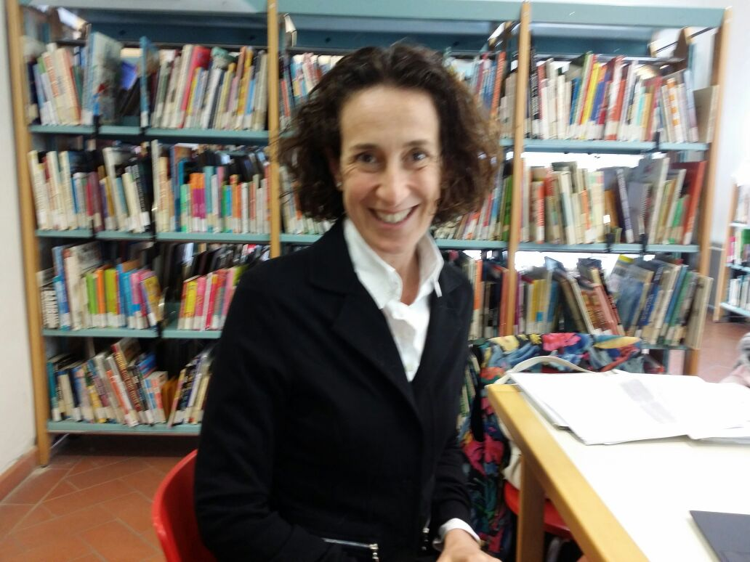

PERSONAL DATA
August 22, 1970, Florence (Italy)
Italian, female
Married to Luciano, 2 children: Emilio and Maria
Via Cantarane 24 – 37129 Verona (Italy)

annalisa.ciampi@univr.it

EDUCATION

PhD, International Law, University of Rome “La Sapienza” - Thesis under the supervision of G. Gaja (1998)

LLM, Harvard Law School (Cambridge, MA) - Subjects of International Law (D. Kennedy), Law of the EU (J.H.H. Weiler), Criminal Law & Procedure and Problems of Law Enforcement (P.B. Heymann) (1996)

Fulbright Scholar to Harvard Law School (Cambridge, MA) (1995-1996)

Degree in Law, cum laude, University of Florence - Specialization in International Law under the guidance of G. Gaja (1993)

Baccalaureate, Liceo Classico “Dante Alighieri”, Florence (1988)

CURRENT POSITIONS

Full Professor of International Law, University of Verona, Law Department (01.01.2012-)

Visiting Professor of European Human Rights Law, Monash University, Faculty of Law (Prato Campus) (01.04.2015-)

PREVIOUS ACADEMIC APPOINTEMENTS

Associate Professor of International Law (2010-2011), Associate Professor of European Union Law (2005-2009), Faculty of Economics, University of Verona

Adjunct Professor of International Law (2006-2013), Assistant Professor of International Law (2000-2005), Research Fellow of International Law (1999-2000), Faculty of Law, University of Florence

Adjunct Professor of European Union Law, Faculty of Literature and Philosophy, University of Florence (2002-2006)

Adjunct Professor of International Law, Faculty of Law, University of Trento (2003-2004)

Adjunct Professor of European Union Law, Faculty of Law, University of Macerata (Jesi) (2002-2003)

Adjunct Professor of International Law, Law Faculty, University of Catanzaro “Magna Graecia” (Cosenza) (2000-2001).

PREVIOUS VISITING PROFESSOR POSITIONS

Visiting Professor of International Law, Academy of European Law Summer School, European University Institute – Specialized Course "Security Council Targeted Sanctions and Human Rights" (2009)

Visiting Professor of International Law, Institut des Hautes Etudes Internationales (I.H.E.I.), Université Panthéon-Assas (Paris II) – Cours magistral "Le règlement des différends de l’OMC" (2008).

INTERNATIONAL APPOINTEMENTS

United Nations Special Rapporteur on the Rights to Freedom of Peaceful Assembly and of Association (01.05.2017-30.11.2017)

Member of the European Committee of Social Rights, Council of Europe (2008-2009)

Expert on the Committee of Legal Advisers on Public International Law (CAHDI), Council of Europe (2004-2008)

Judge Ad Hoc of the European Court of Human Rights, Sivieri and Chiellini v. Italy, Decision of 3 June 2008; Grande Oriente d’Italia di Palazzo Giustiniani v. Italy (II), Judgment of 31 May 2007; Esposito v. Italy, Decision of 5 April 2007

Visiting Professional of the International Criminal Court, Office of the Prosecutor, Legal and Advisory Section, The Hague (2005)

OTHER RELEVANT INTERNATIONAL ACADEMIC & PROFESSIONAL ACTIVITIES

Expert, www.100esperte.it, online databank of experts of International Politics (by Osservatorio di Pavia and Gi.U.Li.A. association, in collaboration with Bracco Foundation and with the support of the Representation of the European Commission in Italy), (2019-)

Amicus Curiae Observations of Prof. Annalisa Ciampi pursuant to rule 103 of the Rules of Procedure and Evidence, Re: "Jordan Referral re Al-Bashir Appeal", Case: The Prosecutor v. Omar Hassan Ahmad Al Bashir, Situation: Situation in Darfur, Sudan, 18 June 2018, ICC-02/05-01/09-363 (Request for leave, 30 April 2018, ICC-02/05-01/09-343; leave granted by Decision on the requests for leave to file observations pursuant to rule 103 of the Rules of Procedure and Evidence, the request for leave to reply and further processes in the appeal, 21 May 2018, ICC-02/05-01/09-351)

External counsel to the Legal Department of the Ministry for Foreign Affairs of Italy, advising on issues of public international law and European Union law (2004-2008)

Legal Adviser for the Civil Parties, Military Court of Appeals of Rome, Public Prosecutor v. Milde Max Josef – Federal Republic of Germany as the party responsible for the civil damage, Judgment of 18 December 2007

Legal Adviser for the Defendant, Corte di Assise of Rome, Public Prosecutor v. Mario Luis Lozano, Judgment of 25 October 2007

Expert for the Government of Italy, Consultation on the Implications for Council of Europe Member States of the Ratification of the Rome Statute of the International Criminal Court, Council of Europe, Athens (2006)

Co-agent for the Government of Italy, written and oral pleadings, European Court of Human Rights (Grand Chamber), Markovic v. Italy, judgment of 14 December 2005

Amicus Curiae Brief to the International Criminal Tribunal for the Former Yugoslavia, "The Objection of the Republic of Croatia to the Issuance of Subpoena Duces Tecum", Prosecutor v. Tihomir Blaskić (with Giorgio Gaja), 1997

OTHER PROFESSIONAL STATUS

Italian Court of Cassation Bar 2008 -

Attorney at Law, Italian Bar of Florence 1996 -

EU RESEARCH PROJECTS AND GRANTS

Marie Curiae Action Supervisor, “The 4th Geneva Convention’s Drafting History as the origin of the Responsibility to Protect (R2P) and Duty to Prevent (D2P)”, Horizon 2020 (Grant Agreement 01.09.2016-31.08.2018)

Marie Curiae Action Supervisor, “The Protection of Civilians and their distinction from Combatants in the 4th Geneva Convention's Drafting Process”, Horizon 2020 (Positive evaluation, Total score: 80.00%; Threshold: 70.0/100.00, 2014)

WP leader, "TransA Transatlantic Relations and the Fragmentation of Global Governance Architectures", WP7 Human rights, Seventh Framework Program (Positive evaluation, 2011)

Member of Research Programmes of Relevant National Interest (PRIN), "Language as a factor of social and political integration", University of Florence (Prof P. Caretti) (2010-2011); "The relevance of human rights norms for international organizations and compliance thereto by member states", University of Florence (Prof G. Gaja), (2006); "The Charter of Fundamental Rights and its implications", University of Florence (Prof G. Gaja) (2000)

EDITORIAL REVIEW AND OTHER RESPONSIBILITIES

Expert Evaluator for the EU Erasmus Plus Programme, The National Institute of Documentation, Innovation and Educational Research (Istituto Nazionale di Documentazione, Innovazione e Ricerca Educativa - Indire, (2020-)

Member of the Board of Editors, Osservatorio sulle fonti (on line) (2009-)

Member of the Scientific Committee, Collana del Dipartimento di Scienze Giuridiche, University of Verona (2013-)

Member of the Board of Directors, Academic Council of the United Nations (ACUNS) (2017-2020)

Referee / Evaluator for the Italian Ministry of Education, “Futuro in Ricerca” 2013 project; SIR projects (2015); VQR 2011-2014 products (2017); PRIN 2017 (2018-)

Assistant Editor, Rivista di Diritto Internazionale (1994-2016)

Member of the Board of Editors, Law & Practice of International Courts and Tribunals (2009-2012)

Submission Editor, Harvard International Law Journal (1995-1996).

AWARDS

Teaching Award, Monash University (QS World University Ranking 2019 No. 59), Faculty of Law (QS World University Ranking 2019 No. 32), in recognition of teaching excellence in achieving outstanding student satisfaction (2018-2019)

Selected Brandon Fellow, Lauterpacht Centre of International Law, University of Cambridge (Cambridge, UK) (2010)

Fulbright Scholar to Harvard Law School (Cambridge, MA) (1995-1996)

Seminario Associazione di Studi e Ricerche Parlamentari “Silvano Tosi”, University of Florence, Grant (1994)

Soroptimist Award for the Best Dissertation Thesis, Law School, Florence (1993)

“Stucchi Prinetti” Award for the Best Graduate, Law School, Florence (1993).

TEACHING ACTIVITIES

Courses and lectures, mostly in English, at BA, MA and PhD Level – with frequent international guest lectures from Cairo University, King’ College, Leipzig University, Leuven University, Liverpool University, Nottingham University, European Commission, ICC Court of Arbitration and others (2000 -):
Public International Law (basic and advanced course)
National Model United Nations
European Union Law
Human Rights Law
Law of International Organizations
International Economic Law
International Arbitration
Competition and EU Market Law

THESIS AND RESEARCH SUPERVISION

Supervisor of BA, MA and Ph.D. thesis, Universities of Florence (2000-2013) and Verona (2005 -):
Public international law
European Union Law

Scientific supervisor of research projects, University of Verona (2008 -):
Dr. Marcello Stella, "The New Forms of International Dispute Settlement between States and Private Parties", International Law (15.07.2016 -)

Dr. Neliana Rodean, "The Right of Access to Internet: Constitutional, Comparative and International Aspects", Constitutional Law (1.07.2014- 2014 al 30.06.2016)

Dr. Mel Marquis, "Multilevel Institutions of Antitrust Governance and International Networks of Compliance", European Union Law (1.11.2008 – 31.08.2011)

Dr. Mel Marquis, "Networks within Networks: EU Competition Policy between European and Global Cooperation in Antitrust and Merger Enforcement", European Union Law (1.04.2012-31.03.2014)

Supervisor of Ph.D. thesis, Université d’Angers (Angers) (2018 -)

Dr. Elisée Judicaël Tiehi, "Les droits procéduraux devant la Cour pénale internationale: essai critique sur le régime de participation des victimes", Pierre Couvrat Droit et Science Politique (Angers) (co-direction with Prof. Renaud-Duparc)

INSTITUTIONAL RESPONSIBILITIES

Holder of various positions of responsibility, Faculty of Economics & Law Department, University of Verona (2005 - )

PROFESSIONAL MEMBERSHIP

Academic Council of the United Nations (ACUNS); American Society of International Law (ASIL); European Federation for Investment Law and Arbitration (EFILA); International Law Association (ILA), Italian branch; Italian Association of Law and Literature (AIDEL); Réseau académique sur la Charte sociale européenne (RACSE), Italian section.

LANGUAGES

Italian (native speaker);
English (fluent);
French (fluent);
Spanish (basic).

OTHER

Member of Osservatorio Europa, Unione delle Camere Penali Italiane (2008-2012)

Member of the Study Group on "International Organisations", International Law Association (2005-2012)

Member of the EUI Working Group on International Criminal Law (Prof Pierre-Marie Dupuy), Department of Law, European University Institute (2002-2008)

External Lecturer, Training Programs, Centre of Excellence for Stability Police Units (CoESPU), Vicenza (2007-2008)

Lecturer of “Public International Law” (advanced course), Post-Graduate Programme on International Studies, University of Florence, in collaboration with the Italian Ministry of Foreign Affairs, Florence (2006-2008)

Scientific Coordination of the Course “International Cooperation in Criminal Matters”, Unione delle Camere Penali di Firenze (in cooperation with Fondazione per la formazione forense, Bar Association of Florence and University of Florence) (2007)

PRESENTATIONS AT NATIONAL AND INTERNATIONAL CONFERENCES (SELECTION)

"Push and Pull: Understanding and Addressing the Root Causes of Mass Displacement and Migration", ACUNS AM18: Human Rights, Migration and Global Governance, Luiss University, Rome, 12-14 July 2018

"History and the Divide between International Economic Law and Human Rights", International Workshop: History and International law: An Intertwined Relationship, University of Verona, Florence, 4-5 June 2018

"Kafka’s Trial and the EU Dublin Asylum System", International Conference: Monstrosity. From the canon to the anti-canon, University of Verona, 22-24 November 2017

"Visual War or the Production / Destruction of International Law through Images", International Conference: Visualizing Law, University of Verona, 11-13 November 2015

"The ICC Cooperation Regime", Expert Workshop: Cooperation and the International Criminal Court, University of Nottingham, Nottingham (United Kingdom), 18-19 September 2014

Book Presentation M. Cartabia et al. (eds.), "Democracy and subsidiarity in the EU. National parliaments, regions and civil society in the decision-making process" (Bologna: Il Mulino, 2013), inaugural session of Summer School on Parliamentary Democracy in Europe, 2nd ed., Luiss University, Rome, 8 July 2013

"Balancing the Rights of the Defense in the ICC", International Conference: Fighting Impunity in a Fragmented World, New Challenges for the ICC, European University Institute, 23-24 May 2008.

MAIN FIELDS OF RESEARCH

Public International Law, International Organisations, International Human Rights Law, International Criminal Law, European Union Law, International Economic Law and the Interface between International Law, History, Art and Literature.

