PERSONAL INFORMATION Erika Bonacci
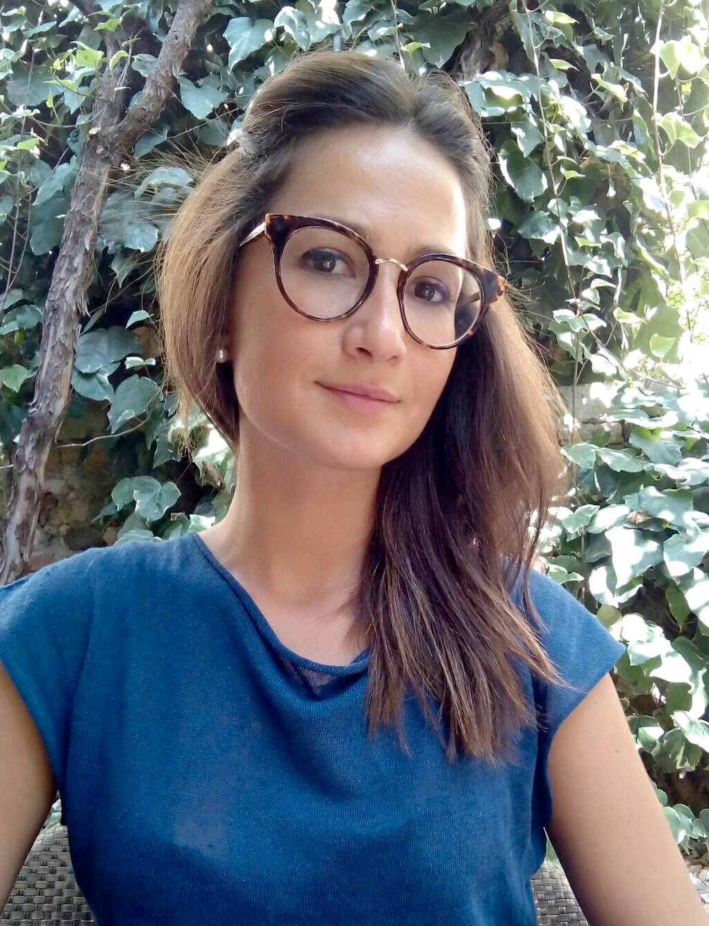
 erika.bonacci@univr.it

Sex Female| Date of birth 01/12/1989 | Nationality Italian

WORK EXPERIENCE

From November 1st 2019 – to
Today

From December 10th 2014 – to
July 23rd 2019

Research Fellow
University of Verona, Eye Clinic
- “Management della superficie oculare in pazienti affetti da patologie del segmento anteriore e candidati alla chirurgia”
Business or sector Cornea and ocular surface

Residency in Ophthalmology
University of Verona, Eye Clinic
- Corneal disease, Medical Retina, Glaucoma, Vitreoretinal Surgery, Glaucoma Surgery Business or sector Ophthalmology
Magna Cum Laude

From July 15th 2014 to 15th September 2014

First Aid Doctor
First Aid Point, Fontane Bianche, Siracusa, Italy
- Medicine
Business or sector First Aid

EDUCATION AND TRAINING

October 5 th-9 ^{th} 2020 ESASO Cornea and Corneal Refractive Surgery e-Module
- eLOS – e Learning Ocular Surgery

June 5 th 2020 ESASO eCampus - Masterclass 1, Pearls on Medical Retina
- eLOS – e Learning Ocular Surgery

September 13th 2020 Immediate Life Support Performer
Verona, Italy
- IRC- Italian Resuscitation Council

January 31st 2020 PCIOLs PATIENT SELECTION TREE
Milan, Italy
  - Premium IOL

May 4th 2018 Fellow of European Board of Ophthalmology
Palais des Congrès, Paris
  - Ophthalmology

May 19th 2017 ESASO – Simulator Training in “Cataract Surgery”
Lugano- ESASO Training Centre, Ospedale Regionale di Lugano (Italiano)

- Cataract Surgery

From October 1st 2009 To July 19th 2013

PERSONAL SKILLS
Graduation in Medicine Magna Cum Laude
University of Catania, Medicine Faculty
- Anatomy, Physiology, Ophthalmology

Mother tongue Italian

Other language
UNDERSTANDING |  | SPEAKING |  | WRITING
Listening | Reading | Spoken interaction | Spoken production

English (FIRST Certificate) B/1 B/1 B/1 B/1 B/1
Levels: A1/2: Basic user - B1/2: Independent user - C1/2 Proficient user Common European Framework of Reference for Languages

Computer skills ▪ECDL Licence

Driving licence ▪B
ADDITIONAL INFORMATION
Scientific Pubblications:

Poster

M.G. Uva, M. Zagari, M. Toro, E. Bonacci. Corso Glaucoma. Trattamenti medico: vecchi e nuovi approcci. Quando iniziare il trattamento. Minerva Oftalmol. Vol 55- Suppl. 1 al N. 1, Marzo 2013.
- M.G. Uva, M. Zagari, E. Bonacci. Dispense. Le nuove associazioni. Minerva Oftalmol. Vol56- . 1 al
N. 1, Marzo 2014.
- M.G. Uva, A. Longo, C. Rapisarda, A. Cantavenera, M. Fallico, M. Reibaldi, E. Bonacci, T.Avitabile. Efficacy of trans-epithelial cross-linking for treatment of progressive keratoconus in pediatric age. ARVO 2014 Annual Meeting. Orange County Convention Center. South Building. Orlando, Florida. May 4-8, 2014.
- Pedrotti E, Bruni E, Bonacci E, Badalamenti R, Mastropasqua R, Marchini G. Comparative Analysis of the Clinical Outcomes with a Monofocal and an Extended Range of Vision Intraocular Lens. J Refract Surg. 2016 Jul 1; 32(7): 436-42.
- Edizione SOI 2016- Chirurgia refrattiva – Ritardi di riepitelizzazione – G. Marchini, E. Pedrotti, E. Bonacci- pag 699-705.
- Edizione SOI 2016- Chirurgia refrattiva – L’addestramento di un nuovo chirurgo e la curva di apprendimento: come fare e cosa evitare - G. Marchini, E. Pedrotti, E. Bonacci- pag 897-900.
- Pedrotti E, Demasi CL, Fasolo A, Bonacci E, Brighenti T, Gennaro N, Ferrari M, Marchini G. Obstructive Sleep Apnea Assessed by Overnight Polysomnography in Patients With Keratoconus. Cornea. 2018 Jan 9.
- Pedrotti E., Carones F., Aiello F, Mastropasqua R, Bruni E, Bonacci E, Talli P, Nucci C, Mariotti C, Marchini G. Comparative analysis of visual outcomes with 4 intraocular lenses: monofocal, multifocal and extended range of vision. J Cataract Refract Surg. 2018 Feb;44(2):156-167
- Pedrotti E, Cozzini T, Fasolo A, Bonacci E, Bonetto J, Merz T, Talli P2 Marchini G. Small-incision lenticule addition in ex vivo model of ectatic human corneas.Int Ophthalmol. 2019 May 13. doi: 10.1007/s10792-019-01106-8.
- Emilio Pedrotti, Grazia Caldarella , Adriano Fasolo, Erika Bonacci, Nicola Gennaro, Alessandra De Gregorio, Giorgio Marchini. Topographic and Biomechanical Changes After Application of Corneal Cross-Linking in Recurrent Keratoconus. Int J Environ Res Public Health,16 (20). doi: 10.3390/ijerph16203872
- Pedrotti E, Chierego C, Bonacci E, De Gregorio A, De Rossi A, Zuliani A, Fasolo A, Marchini G.
New treatments for keratoconus. Int Ophthalmol. 2020 Jul;40(7):1619-1623. doi: 10.1007/s10792-020-01455-9
- Pedrotti E, Carones F, Talli P, Bonacci E, Selvi F, Galzignato A, Besutti A, De Gregorio A, Marchini G. Comparative analysis of objective and subjective outcomes of two different intraocular lenses: trifocal and extended range of vision. BMJ Open Ophthalmol. 2020 Oct 14;5(1): e000497. doi: 10.1136/bmjophth-2020-000497. PMID: 33083552; PMCID: PMC7559032.
- Pedrotti E, Chierego C, Cozzini T, Merz T, Lagali N, De Gregorio A, Fasolo A, Bonacci E, Bonetto J, Marchini G. In Vivo Confocal Microscopy of the Corneal-Conjunctival Transition in the Evaluation of Epithelial Renewal after SLET. J Clin Med. 2020 Nov 6;9(11):3574. doi: 10.3390/jcm9113574. PMID: 33171960; PMCID: PMC7694659.
- Fasolo A, Galzignato A, Pedrotti E, Chierego C, Cozzini T, Bonacci E, Marchini G.Femtosecond laser-assisted implantation of corneal stroma lenticule for keratoconus. Int Ophthalmol. 2021 Feb 24. doi: 10.1007/s10792-021-01739-8. Online ahead of print.PMID: 33625651 Review.
- Pedrotti E, Bonacci E, De Rossi A, Bonetto J, Chierego C, Fasolo A, De Gregorio A, Marchini G. Femtosecond Laser-Assisted Big-Bubble Deep Anterior Lamellar Keratoplasty. Clin Ophthalmol. 2021 Feb 16;15:645-650. doi: 10.2147/OPTH.S294966. PMID: 33623365; PMCID: PMC7896764.

- 8° EuCornea Congress, October 6rd – 7th 2017 - Evaluation of corneal biomechanical behaviour and corneal ex vivo destructive test after different femtolaser-assisted corneal incision patterns for transplantation.
- 8° EuCornea Congress, October 6rd – 7th 2017 - Restoration of normal morphology in corneal ectasia by insertion of a stromal lenticule created by femtosecond laser:an ex vivo preclinical study.
- XXXV Congress of the ESCRS, October 7rd – 11th 2017 – Analysis of the clinical outcomes with diffractive ENLIGHTEN (ENhanced LIGHT ENergy) and an extended-range-of-vision intraocular lens.
- B0043 Erika Bonacci, E. Pedrotti, C. Chierego, J. Bonetto, P. Talli, T. Merz, G. Marchini. FSL- assisted trephinations profiles: “decagonal”,”zig-zag” and “butt-joint”.Eye Clinic University, Verona, Italy. ARVO 2018 Annual Meeting. Hawaii Convention Center. Honolulu, Hawaii. April 29 – May 3

- B0037 Emilio Pedrotti, C. Chierego, E. Bonacci,T. Merz, P. Talli, J. Bonetto, G. Marchini. Intrastromal Keratoplasty: new prospects for the treatment of keratoconus. Ophthalmology, University of Verona, Verona, Italy. ARVO 2018 Annual Meeting. Hawaii Convention Center. Honolulu, Hawaii. April 29 – May 3.
Comunication

- SIGLA/AIGS Congress, June 9th – 11th 2016
- SICSSO Congress, June 23rd – 25th 2016
- 96° SOI National Congress, November 23rd – 26th 2016 - Analisi comparativa dei risultati clinici di 3 differenti modelli di lenti intraoculari che correggono la presbiopia
- 15° SOI International Congress, May 24rd – 27th 2017 - Prevalenza e fattori di rischio di OSA in pazienti affetti da KC
- 15° SOI International Congress, May 24rd – 27th 2017 – Analisi comparativa dei risultati
clinici di dopo impianto di due differenti MIOL: ENLIGHTEN E ERV
- 15° SOI International Congress, May 24rd – 27th 2017- Monitoraggio continuativo della PIO in pazienti con NTG affetti da OSA

- 15° SOI International Congress, May 24rd – 27th 2017 - Prevalenza e fattori di rischio di malattie
oculari in pazienti con sindrome delle apnee notturne: i risultati dello studio SLE.E.P.Y
  - SICSSO Congress, June 22rd – 24th 2017 - Corneal Ulcer in Gorlin-Goltz’s Syndrome
  - 97° SOI National Congress, November 29th – December 26th 2017 - Inserzione di un lenticolo stromale creato con laser a femtosecondi per ripristinare la normale morfologia in cornee ectasiche: uno studio preclinico ex-vivo – E. Pedrotti, C. Chierego, T. Merz, P.M. Talli, E. Bonacci,
J. Bonetto, G. Marchini (Verona)
  - 97° SOI National Congress, November 29th – December 26th 2017- Valutazione dei parametri oculari in una popolazione di pazienti pediatrici affetti da disturbi del respiro – E. Bonacci, E. Pedrotti, T. Merz, P. Talli, J. Bonetto, G. Marchini (Verona)
  - 97° SOI National Congress, November 29th – December 26th 2017-Valutazione della biomeccanica corneale ed ex vivo destructive test dopo esecuzione di incisioni corneali femtolaser-assistite di differenti morfologie finalizzate al trapianto E. Pedrotti, C. Chierego, J. Bonetto, E. Bonacci, P. Talli, T. Merz, G. Marchini (Verona)
  - II sessione DISTURBI RESPIRATORI DEL SONNO: Esperti a confronto. May 11st 2018, Verona. Azienda Ospedaliera Universitaria Integrata, Verona. PATOLOGIA OCULARE E DRS: LE EVIDENZE DI UN RAPPORTO NON VIRTUOSO. A. Fasolo, E. Pedrotti, T. Cozzini, E. Bonacci,
G. Marchini.
  - 16° SOI International Congress May 16th – 18th 2018. SIMPLE LIMBAL EPITHELIAL TRANSPLANTATION (SLET): una possibile alternativa per il trattamento dei deficit di cellule staminali limbari. E. Pedrotti. T. Merz, E. Bonacci, J. Bonetto, C. Chierego, P.M. Talli, G. Marchini
  - 16° SOI International Congress May 16th – 18th 2018. IOL EDOF REFRATTIVE NEL MIOPE: UNA NON CONTROIDICAZIONE. E. Bonacci. E. Pedrotti, P.M. Talli, T. Merz, A. Galzignato, F. Selvi, J. Bonetto, G. Marchini
  - SICSSO Congress, June 21st -23rd 2018. Femtosecond deep lamellar keratoplasty for management of Keraklear artificial corneal extrusion (*Giovani Oculisti Italiani - GOI) E. Bonacci, J. Bonetto, E. Pedrotti (Verona)
  - 98° SOI National Congress, November 28th- December 2nd 2018. “Chirurgia tradizionale VS Mininvasiva: opportunità o limite per il giovane chirurgo?” (*Giovani Oculisti Italiani - GOI)
  - 35° SOT Annual Congress, May 17th 2019. Sessione I La novità di quest’anno : Caso clinico 3. Un nuovo approccio alla patologia Cheratoplastica intrastromale per il trattamento del cheratocono E. Bonacci
  - SICSSO Congress, une 27st -29rd 2019. Twelve month follow up of intrastromal keratoplasty: new perspectives for the treatment of keratoconus Best paper contest for Ophthalmologists under 40) E. Bonacci, E. Pedrotti, J. Bonetto, T. Cozzini, , G. Caldarella, A. Galzignato, T. Merz, P. Talli, G. Marchini(Verona)
  - SICSSO Congress, June 21st -23rd 2018. Identification of FS-assisted wound configurations to provide less astigmatism and higher corneal biomechanical stability: “zig-zag” and “butt-joint” cutting profiles. Poster Area. E. Pedrotti, C. Chierego, J. Bonetto, E. Bonacci, P. Talli, T. Merz, G. Marchini (Verona)

Awards

References

- Thea Trophy Contest Edition 2016/2017- National Italian Winner on the theme: Non- Surgical treatment of corneal disorders

Prof. G. Marchini, Chief of Department of Ophthalmology, University of Verona +39 0458122340

I hereby authorize treatment of my data according to the applicable local regulation about data protection and any further amendments”
Updated on March 5th 2021

Dott. Erika Bonacci

